4. Import documents making
(InBound Doc module, according to export documents, in the ship to Hong Kong post production import documents)

Now, the ship pulled up to the port of Seattle, the Seattle office processing business to deal with the import documents.

4.1 import import manifest data
Back to the master station, double-click the icon InBound Doc, enter the system import documents module.
Enter, in the interface, click in the pop-up interface, click on, can list all of the import documents data, as well as the processing state, as shown in figure 2-27.
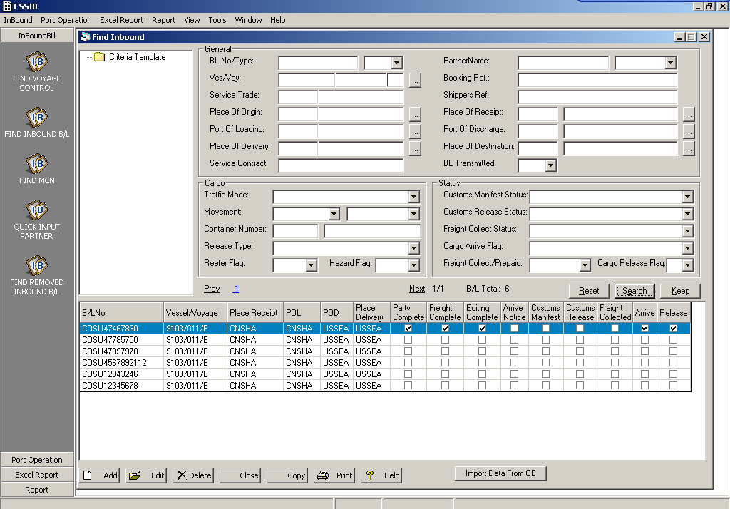
Figure 2-27
Just click on the button below the interface, the interface of the popup input corresponding exports edited the bill of lading number, as shown in figure 2 - 28, and click on the button, you can import export data, it is then automatically into the import manifest editor interface, as shown in figure 2-29.

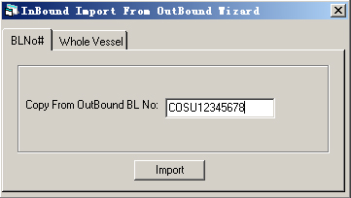
Figure 2 - 28
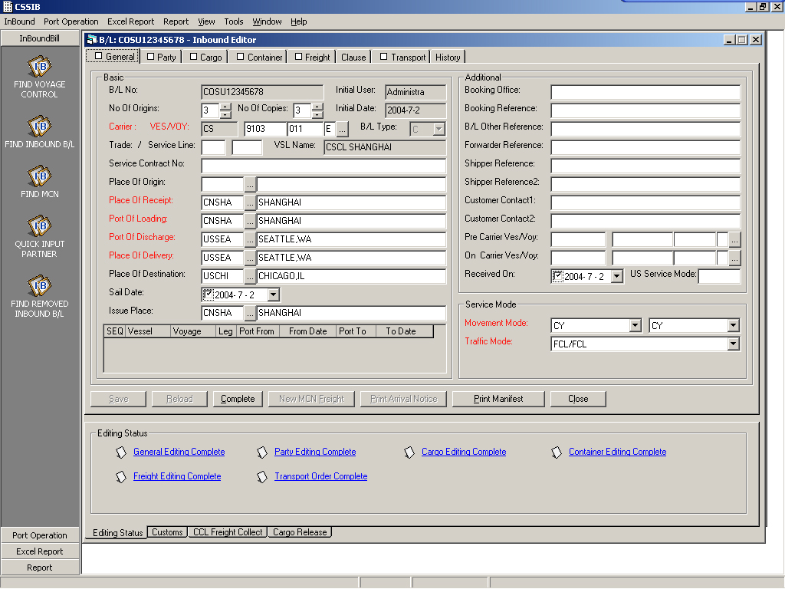
Figure 2 - 29

4.2 data confirm
In figure 2-29, click on each page, respectively in each page, click on the data confirm that finish. At that time, the interface of each page display place will set the hook, such as Figure 2 - 29. As for the【Transport】page, is about inland transportation, this part of the content can be ignored.
Figure 2 - 30
4.3 import release cargo
Upon confirmation of goods have to port, when the consignee to pick up the goods, can put the goods, and record release cargo information.
In the bottom of the interface, select the Cargo Release page, as shown in figure 2-31.
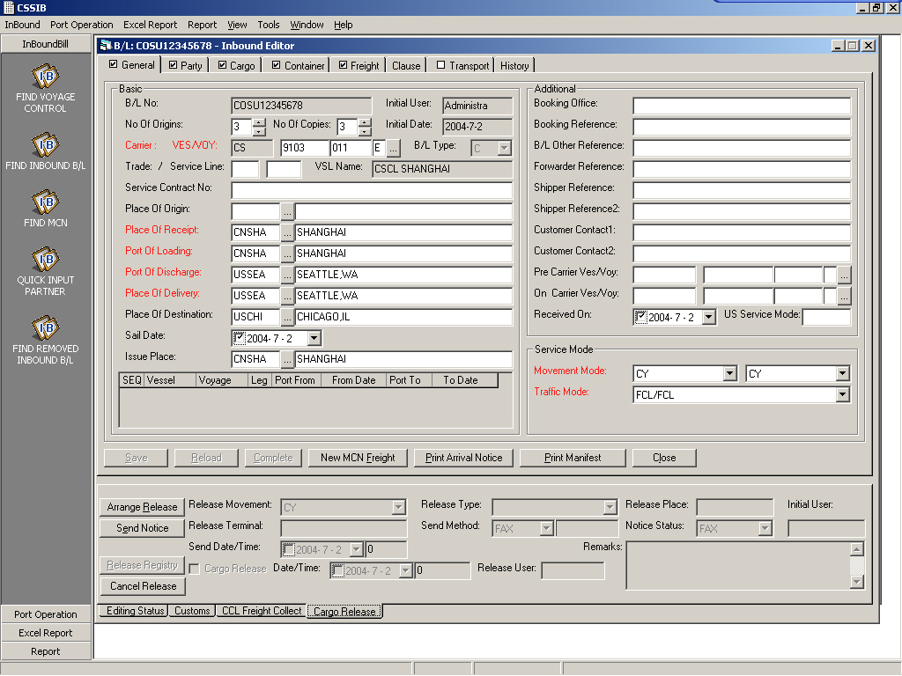
Figure 2 - 31
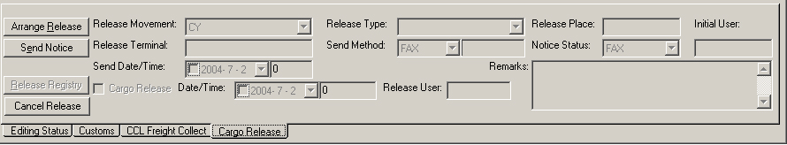

Click, the system pop-up a release cargo arrangement of edit box, as shown in figure 2-32.
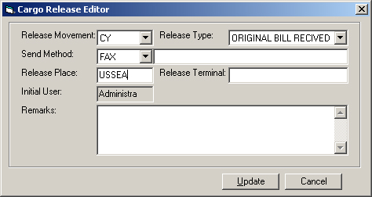
Figure 2-32
Choose fill the(CY)(FAX)【Release Type】(original bill received),【Release Place】(UUSEA)the data,input after click OK.
Next, can send the arrival of the notice. Click, choose way and number().
Customer formal delivery, click, in dialog interface (figure 2-33) that release cargo time,click again on the, complete release cargo registration.
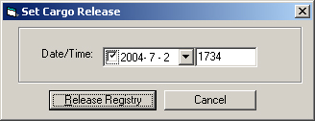
Figure 2 - 33

So far, a goods from export to import all the business is done. Students can practice a few transaction.

软件界面英文含义表
模块 | 界面 | 英文 | 中文解释
BK | 订舱常规页 | Booking Number | 订舱号
BK | 订舱常规页 | Booking Office | 订舱部门,订舱办事处（指船公司的口岸办事处）
BK | 订舱常规页 | POR | 收货地(Place of Receipt)
BK | 订舱常规页 | Cutoff D/T | 截关时间
BK | 订舱常规页 | POL/Terminal | Port of Loading装货港/码头泊位
BK | 订舱常规页 | POL ETD | 装货港预计离泊时间（Estimated Time of Departure）
BK | 订舱常规页 | POD | 卸货港（Port of Discharge）
BK | 订舱常规页 | POD ETA | 卸货港预计抵达时间（Estimated Time of Arrival）
BK | 订舱常规页 | Delivery | 交货地
BK | 订舱常规页 | Del ETA | 交货地预计抵达交货地时间
BK | 订舱常规页 | Copy From Booking | 被拷贝的原始单号
BK | 订舱常规页 | Shipper Reference | 托运人编号
BK | 订舱常规页 | Customs Reference | 海关编号
BK | 订舱常规页 | Proof of Export | 出口许可证
BK | 订舱常规页 | SC./Agreement Type | 合约类型(订舱单位和船公司的合约)
BK | 订舱常规页 | SC./Agreement Number | 合约号
BK | 订舱常规页 | Sales Representative | 客户代表
BK | 订舱常规页 | Sales Office | 销售部门
BK | 订舱常规页 | B/L Release Office | 签单部门
BK | 订舱常规页 | Equipment Office | 放箱部门
BK | 订舱常规页 | Booking Party | 订舱方(互换舱位)
BK | 订舱常规页 | Shipment Control Party | 承运控制合作方(互换舱位)
BK | 订舱常规页 | Documentation Cut Off Date/Time | 舱单截至时间
BK | 订舱常规页 | FF Code | 货代代码 Forwarder Code
BK | 订舱常规页 | CNEE | 受货人 Consignee
 |  | Carrier | 承运人
OB | 出口提单常规页 | BL Type | 签单方式
OB | 出口提单常规页 | Service Contract No. | 合约号
OB | 出口提单常规页 | Trade: / Service Line | 贸易航线
OB | 出口提单常规页 | BL Other Ref#: | 提单其他参考号
OB | 出口提单常规页 | 起始地代码/名称 | 始发地代码/名称
IB | 进口单证 | No Of Originas: | 正本提单份数
IB | 进口单证 | No Of Copies: | 副本提单份数
IB | 内陆运输 | Depot | 仓库
IB | 内陆运输 | Movement Discharge | 运输条款
IB | 内陆运输 | Carrier－Merchant | 承运方还是委托方负责运输
IB | 内陆运输 | Transport Type | 运输方式
IB | 内陆运输 | Order No. | 工作单号码
IB | 内陆运输 | Vendor Code | 合作方代码

Common problem
A Booking module, common problems
(1) ask: why the Equipment page save, always error?
A: check Equipment and Cargo pages of goods number, volume (two), weight (two) is consistent.
(2) some of the Booking port choose wrong, lead to the back can't find route, i.e., the route choice behind no this port.
Second, OB module common problem
(1) ask: why the Import Data From OB, input OB BL number, go wrong?
A: check the OB modules, each page is in Complete button.
Check General page Proof of Export field is not more than 5 a pure digital.
Check the OB module port and address information is correct, can appear otherwise can't find route control error messages)
Three, AR/AP module common problem
(1) q: create AR invoice, can't find OB single.
A: check the OB modules, each page is in Complete button.
(2) q: for collection Allacate invoice, can't find invoice.
A: Check receipt records (i.e., Check Check) of the payer and invoice payer is consistent, and is the owner.
In the check window, press Select invoice button, remove customter conditions, can be found by the Payer, but if not, behind also will have a problem.

